Active and Passive Components in
Electronic Circuits

Shashank Nandan
IEEE Student Branch Manipal
Manipal Institute of Technology
Karnataka, India
shashanknandan21@gmail.com

Abstract—Electronic circuits consist of a combination of active and passive components, each serving a unique role. Active components, such as transistors and operational amplifiers, enable amplification and control of electrical energy, while passive components, including resistors and capacitors, regulate and store energy. This paper explores the types of active and passive components, their classifications, working principles, and applications. Key classifications, such as ideal versus practical sources and dependent versus independent sources in active components, as well as linear, bilateral, and lumped elements in passive components, are thoroughly analyzed. The report emphasizes their interplay in circuits, presenting a comprehensive understanding of their functionality in various electronic applications.
Keywords—Active Components, Passive Components, Voltage Sources, Current Sources, Transistors, Resistors, Capacitors, Electronic Circuits

Introduction
Electronic circuits are built upon two fundamental categories of components: active and passive. Active components have the capability to control and amplify electrical energy, powered by an external source. Passive components, on the other hand, lack this ability but are essential for storing and dissipating energy. The classification of these components provides insight into their operational roles within circuits.
This report delves into at types of active and passive components, exploring their working principles and real-world applications. It also examines the classification of sources (ideal, practical, dependent, and independent) and characteristics of passive components (linear, bilateral, and lumped).

Active Elements

Active Elements And Active Components
There is a subtle difference between active elements and active components in the context of electrical circuits. Active elements are capable of delivering energy for an infinite duration of time whereas active components control the flow of current and require an external power source to operate.
Active elements are parts of a circuit that can introduce energy into the system. They can provide power or amplify signals. Examples of active elements are independent sources like voltage and current sources (batteries, power supplies) and dependent sources like controlled voltage or current sources.
Active components are physical devices or elements that can amplify, switch, or generate signals. They often rely on external power to operate. Examples are transistors like BJT MOSFET, Op-Amps, ICs etc. Active components are typically characterized by their ability to control current or voltage in a circuit, often requiring biasing from an external source. Therefore, all active components are active elements, but not all active elements are necessarily active components.

Classification
Ideal Sources: Deliver constant voltage or current irrespective of load.
Practical Sources: Include internal resistance, leading to slight deviations in output based on load [1].
Independent Sources: Output remains fixed, unaffected by circuit conditions.
Dependent Sources: Output depends on another parameter within the circuit, such as current or voltage at a different point [2].

Types OfActive Elements

Diodes
Diodes are fundamental electronic components that serve as unidirectional current controllers. Working of a diode is based on fact that they allow current flow in one direction, blocking it in the reverse.
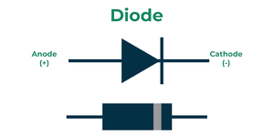
The introduction of semiconductor materials like silicon and germanium revolutionized diode technology, enabling the development of compact, efficient, and versatile devices. The operation of diodes is based on the PN junction, where the interaction between p-type and n-type semiconductors creates a depletion region. This region governs the diode’s ability to conduct current under specific conditions, defining its behaviour in forward and reverse bias. Hence, diode acts as electronic switch
•Forward Bias: Applying a positive voltage to the p-side and a negative voltage to the n-side reduces the potential barrier, allowing current to flow through the diode.
•Reverse Bias: Reversing the voltage polarity increases the potential barrier, preventing significant current flow except for a small leakage current due to minority carriers
Applications: Rectification, signal demodulation, and voltage clamping, circuit protection, LED’s [5].

Operational Amplifiers (Op-Amps)
An Operational Amplifier (Op-Amp) is a high-gain electronic voltage amplifier with differential inputs and typically a single-ended output. It amplifies the difference between its input voltages, making it ideal for various analog signal processing tasks.
Op-Amps are active elements because they require an external power supply to operate and amplify input signals. They can provide energy to the circuit, enabling applications such as signal amplification, filtering, and waveform generation.
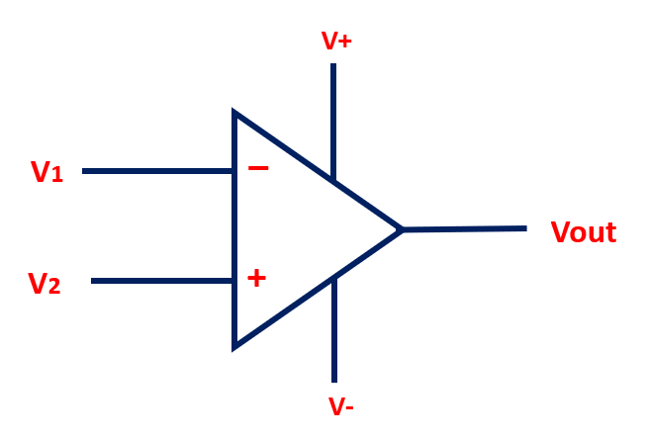
The basic working principle involves two inputs: the inverting (-) and non-inverting (+) terminals. The Op-Amp amplifies the voltage difference between these inputs and outputs the result, scaled by its gain. Feedback mechanisms control this gain for desired performance.
Applications of Op-Amps include signal amplification in audio systems, active filters for signal processing, comparators in control systems, oscillators and waveform generators, and performing mathematical operations like addition and integration in analog computers.

Transistors
Define They act like a switch with no moving parts. Amplification(generally of a weak signal) is the basic function of transistor. These are the semiconductor devices that amplify and switch signals. These operate in cutoff, active, and saturation modes.
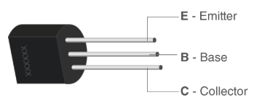
Transistors are considered active components as they amplify electrical signals, switch current, and control the flow of energy in a circuit. Their ability to inject/modulate energy in a circuit makes them very widely used active components. On the same principle as diodes, they are formed of two semiconductor types placed together in a specific layout to create a depletion region and then manipulate that depletion region with current/voltage to perform switching operations.
Bipolar Junction Transistors in which include NPN and PNP transistors are further classified based on their applications and characteristics:
NPN Transistor: The NPN transistor is commonly used for the amplification and switching in electronic circuits. It is named after the arrangement of its layers: N-type collector, P-type base, and N-type emitter.
PNP Transistor: The PNP transistor is also used for the amplification and switching but with the opposite current flow compared to NPN.
Applications: Used in amplifiers, oscillators, switching and digital circuits [3].

Batteries
A battery is an electrochemical device that converts stored chemical energy into electrical energy, providing power to electronic circuits. As an active element, it delivers energy independently, driving current through the circuit without requiring an external source.
Primarily functioning as a voltage source, a battery maintains a constant potential difference across its terminals (e.g., 1.5V for alkaline batteries). It can also serve as a current source in current-regulated applications like LED circuits. Batteries store energy chemically and release it electrically, enabling active circuit components like transistors and operational amplifiers to operate.
Key characteristics include internal resistance, capacity (measured in ampere-hours), and rechargeability (e.g., lithium-ion batteries). Common applications include powering portable devices, IoT systems, backup power supplies, and electric vehicles. In essence, a battery is an active element because it supplies energy directly, enabling current flow and ensuring the functionality of electronic systems.

Integrated Circuits
Integrated Circuits (ICs) are small semiconductor chips that integrate millions of electronic components like transistors, resistors, capacitors, and diodes into a single package. They perform various complex functions, such as amplification, signal processing, digital calculations, and specialized tasks like microprocessors and memory storage. ICs significantly enhance the efficiency of electronic devices by reducing their size, power consumption, and manufacturing costs.
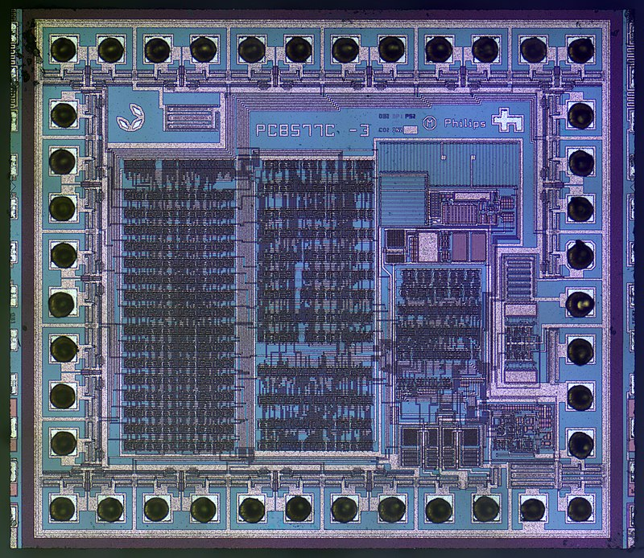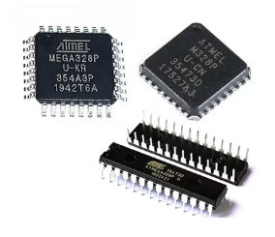
ICs can function as amplifiers, oscillators, timers, counters, logic gates, microcontrollers, or microprocessors, making them versatile components in modern electronics. Their applications include reducing component size, improving power efficiency, and integrating multiple components into a compact form factor. These features make ICs critical in devices like computers, smartphones, and industrial systems, enabling advanced capabilities and compact designs. There are multiple ICs that perform multiple types of tasks like NE555 timer is used for time delay/pulse operation whereas Memory ICs – RAM, ROM and flash memory .

Passive Elements

Passive Elements and Components
Active components can deliver or control the power by the help of other electrical signals. For example, I give a signal of a sinusoidal waveform at diode input, but the diode gives the output of rectified and I got the non-sinusoidal wave, But if I give a signal at any resistor, any inductor or capacitor then the output from these are the same waveform as input. Passive components didn’t deliver or control the power, it consumes the power. Those elements can’t change the waveform of electrical energy, called Passive elements. Passive components neither generate nor amplify energy; they store or dissipate it.

Classification
1.Linear Components: Exhibit a linear relationship between input and output (e.g., resistors).
2.Bilateral Components: Conduct equally in both directions (e.g., resistors, inductors). If the polarity of the voltage is changed then the characteristics of V-I remain same, then the element is bilateral. The best example of a bilateral element is a transmission line or any conducting wire. if I connect the wire by the changing of its terminals. Then no any change occurs in the circuit. In the case of the generalized plane, the characteristics of the Bilateral element is always Symmetrical about the origin.
3.Lumped Elements: Localized components, as opposed to distributed elements like transmission lines [8].

Types Of Passive Elements

Resistors
A resistor is an electronic component that limits or regulates the flow of electric current in a circuit by providing resistance, measured in ohms (Ω). It converts electrical energy into heat as it opposes the current. Resistors are considered passive elements because they cannot generate or amplify electrical energy; they only consume or dissipate energy supplied by an external source. A resistor is an electronic component that limits or regulates the flow of electric current in a circuit by providing resistance, measured in ohms (Ω). It converts electrical energy into heat as it opposes the current. Resistors are considered passive elements because they cannot generate or amplify electrical energy; they only consume or dissipate energy supplied by an external source.
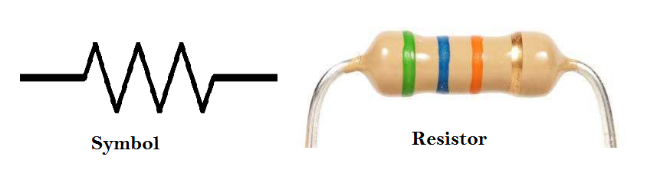
Key types include:
1. Fixed Resistors: These resistors maintain a constant resistance. Carbon film, metal film, and wire-wound resistors are common examples. Carbon resistors are widely used in low-power applications due to their affordability, while metal film resistors offer precision in circuits requiring stability.
2. Variable Resistors: These allow resistance adjustment, as seen in potentiometers and rheostats, useful in volume control and calibration applications.
3. Special Resistors: Thermistors, which vary resistance with temperature, and photoresistors, which are light-sensitive, serve specialized purposes in sensors and thermal protection systems.

Capacitors
A capacitor is an electronic component that stores and releases electrical energy in the form of an electric field. It consists of two conductive plates separated by an insulating material called a dielectric. Capacitors are considered passive elements because they do not generate or amplify electrical energy; instead, they store energy temporarily and release it without adding any power to the circuit.
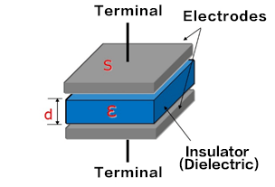
Capacitors have applications in Filtering, energy storage, and timing circuits [10].
Capacitors store electrical charge and are classified based on dielectric material and application:
- Electrolytic Capacitors: High capacitance values for energy storage, used in power supplies.
- Ceramic Capacitors: Compact, high-frequency operation, ideal for signal coupling.
- Film Capacitors: Reliable for AC applications due to stability.
Supercapacitors: Exhibit extremely high capacitance, allowing rapid energy storage and discharge. Their ‘super’ property lies in the double-layer capacitance, which increases surface area for charge storage.

Inductors
An inductor is a passive electronic component that stores energy in a magnetic field when electrical current flows through it. It is made of a coil of wire wound around a core made of air or magnetic material. Inductors oppose changes in current through the principle of induction. When the current passing through an inductor changes, the magnetic field around it also changes, inducing a voltage that opposes the variation. This property, described by Faraday's law, makes inductors essential in circuits.
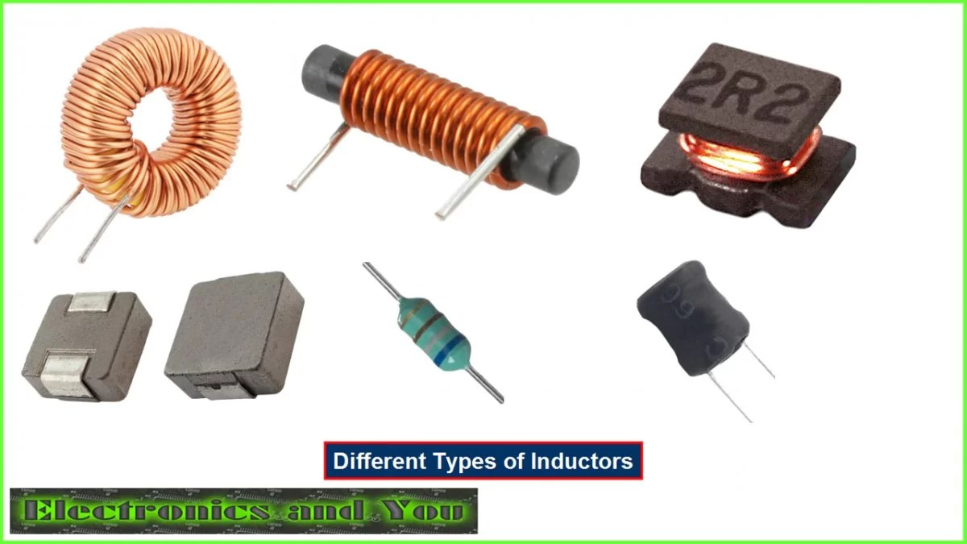
Inductors are widely used in applications such as filtering out noise, tuning, and selecting specific frequencies in radio frequency circuits, and energy storage. They are considered passive elements because they cannot generate or amplify energy; instead, they store energy temporarily in their magnetic field and release it back into the circuit. This makes them integral to many electrical and electronic systems.

Crystal Oscillators
A crystal oscillator is an electronic component that uses the piezoelectric property of quartz crystals to generate precise frequency signals. When an electric field is applied to the crystal, it vibrates at a natural resonant frequency determined by its physical dimensions and material properties. These vibrations are converted into stable electrical oscillations, which are used in circuits requiring accurate timing and frequency control.
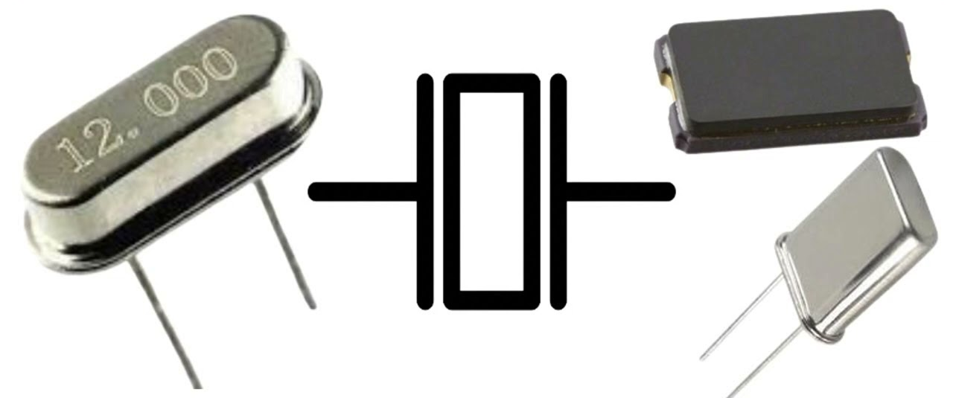
Crystal oscillators are widely used in timekeeping devices such as clocks and watches, as well as in communication systems for frequency generation and signal stability. They are considered passive elements because the crystal itself does not amplify or generate energy independently; it relies on an external circuit to initiate and sustain oscillations. The crystal’s role is to provide a stable reference frequency, making it a crucial but inherently passive component in electronic systems.

Transformers
A transformer is a passive electrical device that transfers electrical energy between two or more circuits through electromagnetic induction. It works by using a primary coil and a secondary coil, with a changing current in the primary coil creating a varying magnetic field that induces a voltage in the secondary coil. The relationship between voltage and current in the transformer is described by the equation V1I1 = V2I2, where V1 and I1 are the voltage and current in the primary coil, and V2 and I2 are those in the secondary coil. This means the power (P = V × I) remains constant, so there is no power gain in the transformer.
Because a transformer cannot generate or amplify power, only transferring it, it is considered a passive element. Transformers are essential in power systems for voltage step-up and step-down applications, allowing efficient transmission and distribution of electrical energy.
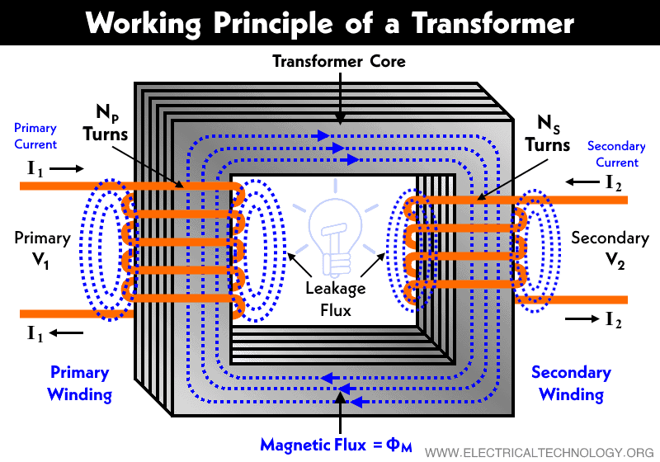
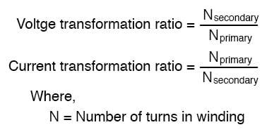

Aspect of Power and V/I Curve
In electrical circuit analysis, the sign of power indicates whether a component is absorbing (passive) or delivering (active) power. This concept is based on the passive sign convention and helps in analyzing circuit behavior effectively.

Mathematical Aspect
Power is calculated using the formula P=VI, where P represents power, V the voltage and I the current. As per conventional current flow If current Ienters through the positive terminal of the voltage V,the power is positive (absorbed).If current I exits through the positive terminal of the voltage, the power is negative (delivered).
Positive power means that the component is absorbing power, acting as a sink. Example: Resistors, capacitors (during charging), inductors (during energy storage), and devices like light bulbs and heaters. Positive power is typical for passive components, which consume energy supplied by the circuit.

Graphical aspect
Graph of the active component is negative slope and lie in the 2nd or 4th quadrant. Graph of Passive component is lie in 1st or 3rd quadrant and positive slope. In graphical representation, if any of the region of the curve lies in the in 1st /3rd quadrant with +ve slope, then it doesn’t matter that what other parts of the curve represents, the circuit will be overall acting as an active circuit. This is because it has the ability to supply energy (second quadrant) and exhibits characteristics (negative slope) that cannot be achieved by passive components.
Thus, an element with a VI curve in both the first and second quadrants and both positive and negative slopes is an active element.
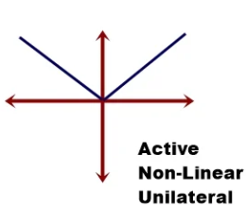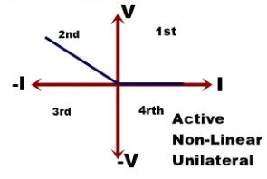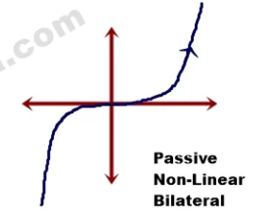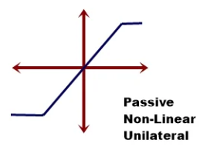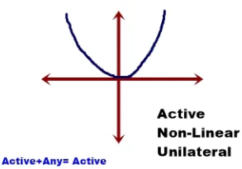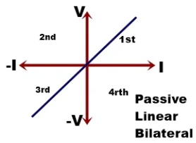

Practical Applications
The classification of components influences circuit design. For instance, using practical sources instead of ideal ones ensures realistic operation. Similarly, combining active and passive components, like transistors with resistors, enhances functionality in amplifiers and oscillators.
Questions such as the practicality of supercapacitors in energy storage and wireless energy transfer highlight the interplay between component types. Supercapacitors, for instance, bridge the gap between capacitors and batteries, offering higher energy density [14].

Conclusion
Active and passive components form the backbone of modern electronic circuits. Active components amplify and control signals, while passive components manage energy dissipation and storage. The classification into ideal and practical, dependent and independent sources for active components, and linear, bilateral, and lumped categories for passive components, provides a comprehensive framework for circuit design. Understanding their working and applications ensures efficient use in diverse applications, from signal processing to energy management.

Acknowledgment
I would like to express my gratitude to the IEEE-SBM at Manipal Institute of Technology, Manipal Academy of Higher Education, for providing me with the opportunity to contribute to this report under the Electronics domain. This has been very informative and resourceful for me and I am grateful for being able to express my opinions on the topic.

References

- Tutorialspoint. "Difference Between Active and Passive Components in Electronics." Available: https://www.tutorialspoint.com/difference-between-active-and-passive-components-in-electronics
- Wikipedia. "Active Components." Available: https://en.wikipedia.org
- HyperPhysics. "Semiconductor Devices." Available: https://hyperphysics.phy-astr.gsu.edu
- Electronics Tutorials. "Operational Amplifiers." Available: https://www.electronics-tutorials.ws/opamp
- Britannica. "Diodes." Available: https://www.britannica.com/science/diode
- LibreTexts. "Phototransistors." Available: https://phys.libretexts.org
- CK-12. "Thyristors and SCRs." Available: https://www.ck12.org
- Khan Academy. "Passive Circuit Components." Available: https://www.khanacademy.org
- NASA. "Resistor Fundamentals." Available: https://www.nasa.gov
- MIT OCW. "Capacitor Functionality." Available: https://ocw.mit.edu
- Electronics Tutorials. "Inductors and Applications." Available: https://www.electronics-tutorials.ws/inductor
- H. C. Verma, Concepts of Physics.
- Khan Academy. "Crystal Oscillators." Available: https://www.khanacademy.org/science/physics
- Wikipedia. "Supercapacitors." Available: https://en.wikipedia.org

